**Key tool commands and screenshots**

Running these commands for creating both side certificates:

1. keytool -genkey -alias encrypt -keyalg RSA -keystore "C:\Test\encrypt.jks"
2. keytool -export -alias encrypt -file "C:\Test\encrypt_cert.cer" -keystore "C:\Test\encrypt.jks"
3. keytool -genkey -alias decrypt -keyalg RSA -keystore "C:\Test\decrypt.jks"
4. keytool -export -alias decrypt -file "C:\Test\decrypt_cert.cer" -keystore "C:\Test\decrypt.jks"

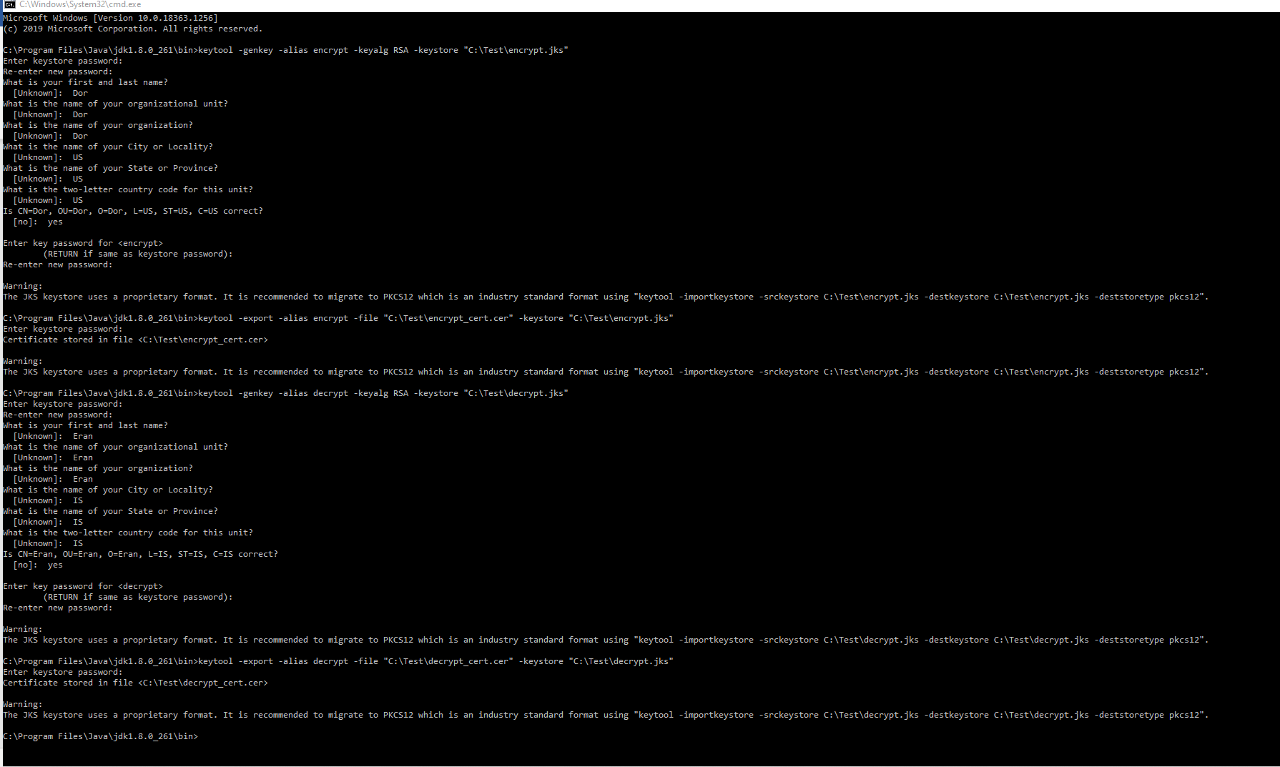

Running these commands to create trusted certificates:

1. keytool -import -trustcacerts -file "c:\Test\decrypt_cert.cer" -alias decrypt -keystore "C:\Test\encrypt.jks"
2. keytool -import -trustcacerts -file "C:\Test\encrypt_cert.cer" -alias encrypt -keystore "C:\Test\decrypt.jks"

